**ADMIN LOGIN**

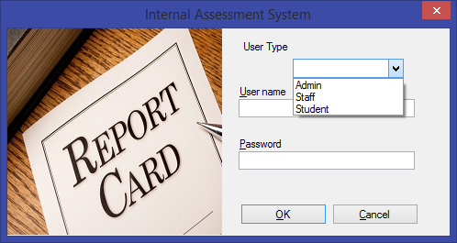

This screenshot is login page. Either student, staff or admin can login the page by giving username and password provided.

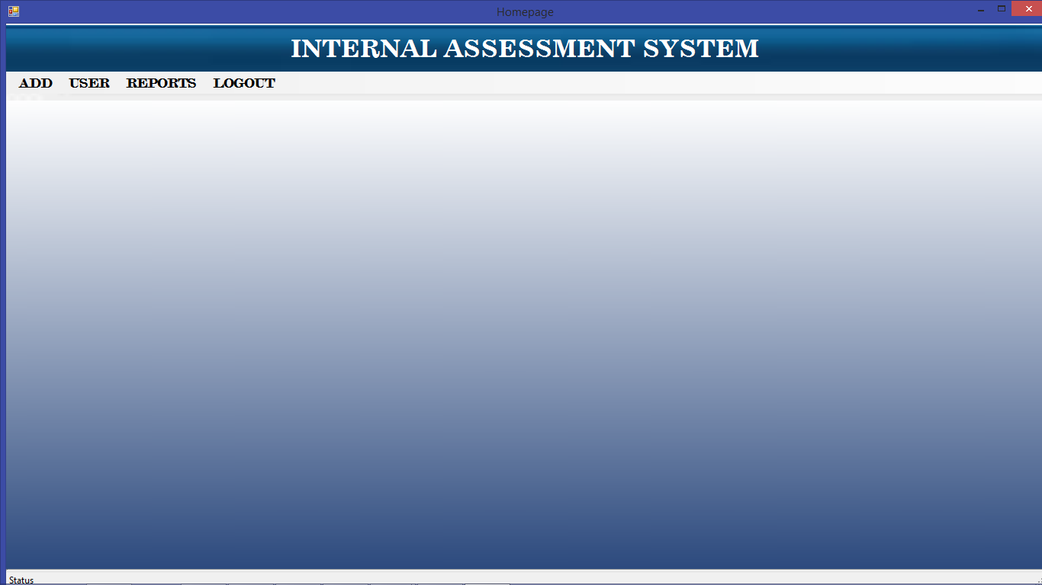

Admin homepage it has the following link:

Add User Reports Logout

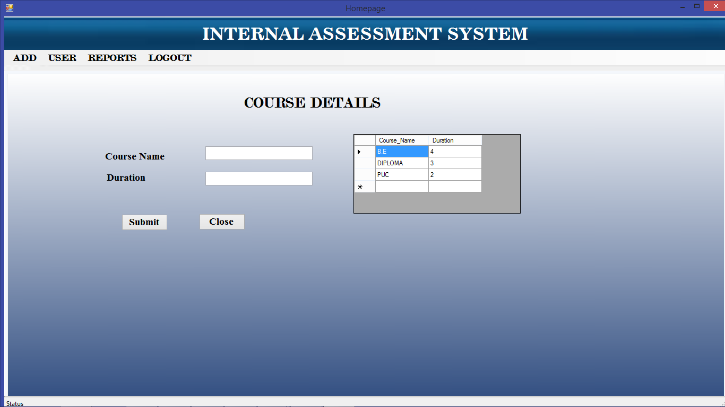This screenshot contains the course Details which we can enter the course name like BE, Diploma and PUC and also the duration in hours. Then submit the button or close the button.

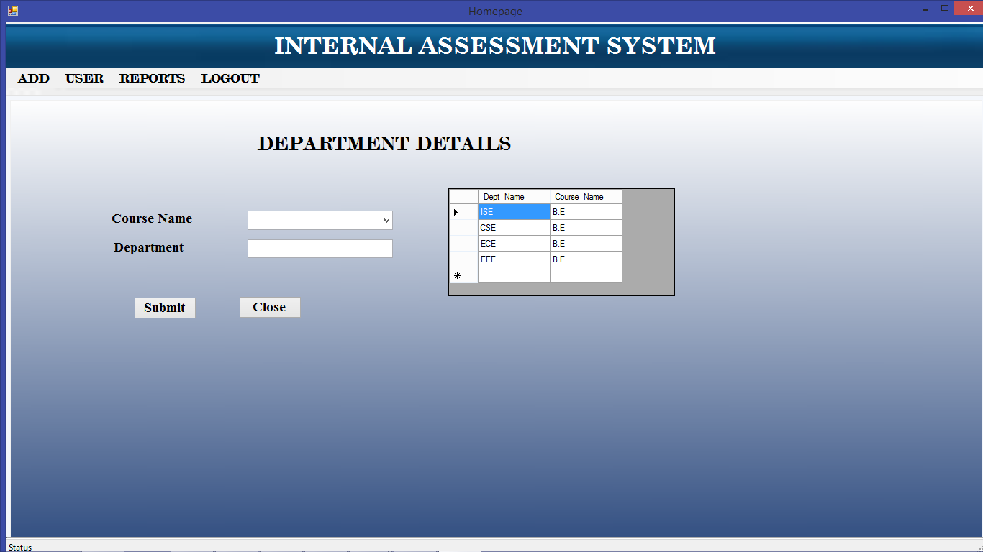

We will enter the details of Department by entering the course name like BE, Diploma etc. and we will enter the department name has ISE, CSE, ECE, or EEE and submit the button or close button.

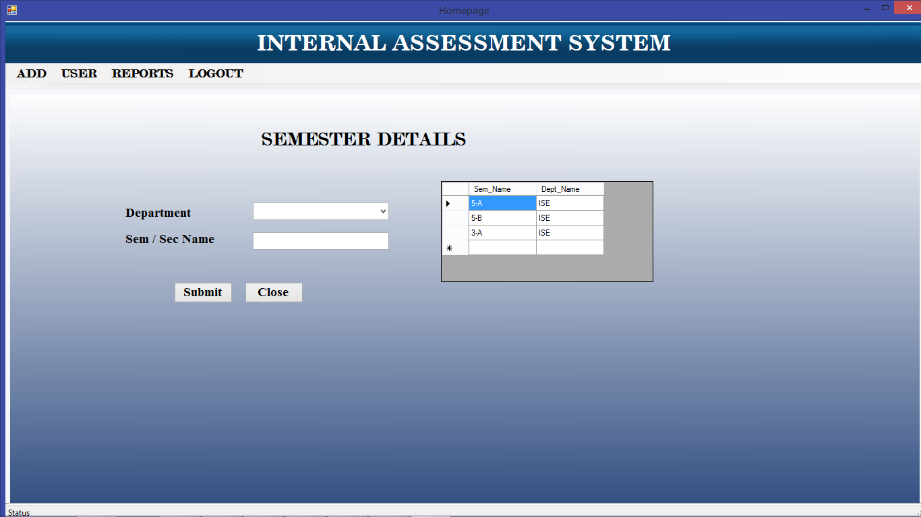

This screenshot must enter the semester details. we must enter the department name and semester or section name like 3-A,3-B, 5-A,5-B etc. after entering the details we click on submit button or close button.

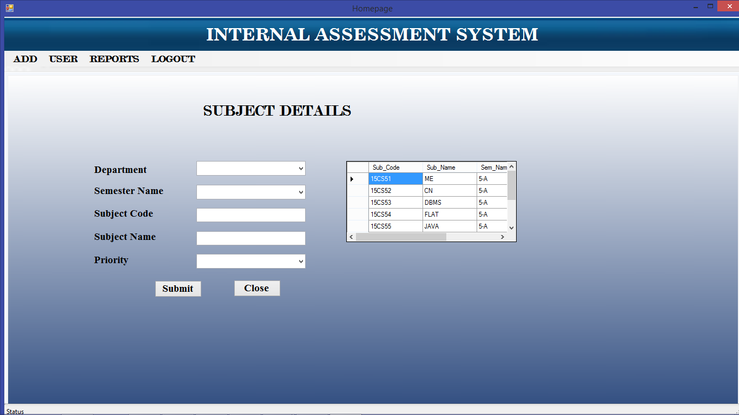

We should enter the details of subject of semesters. we should enter the department name, semester name, subject code of each semester along with subject name and which priority that subject contains like first , second etc. then submit the button to store it in the database or close the button.

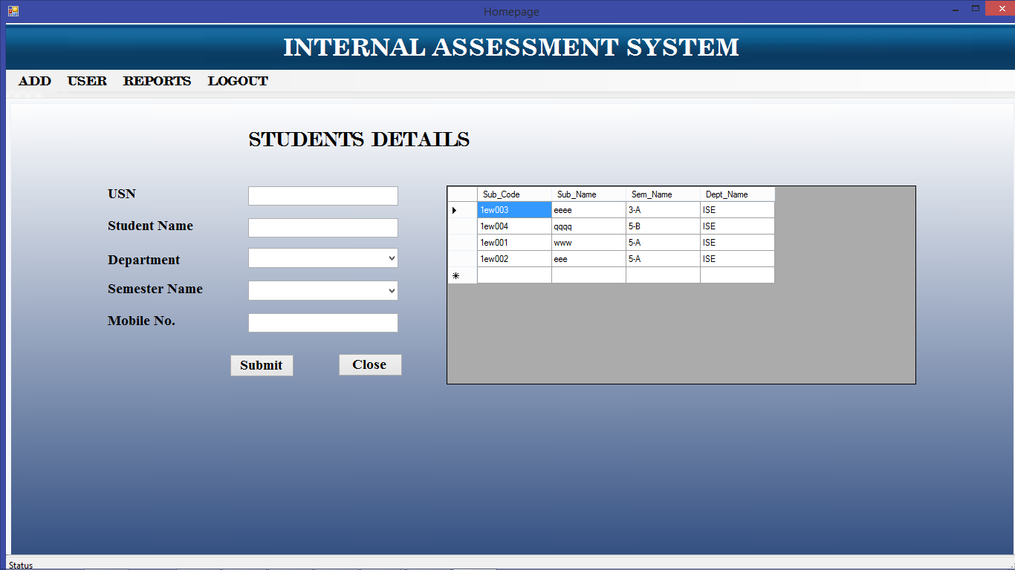

Now, this screenshot contains to enter the students details. We should enter the details of students like USN, Student Name, department name, semester name and mobile no of each student. This entered details will be stored in the database when we submit the button submit if not we can close the button.

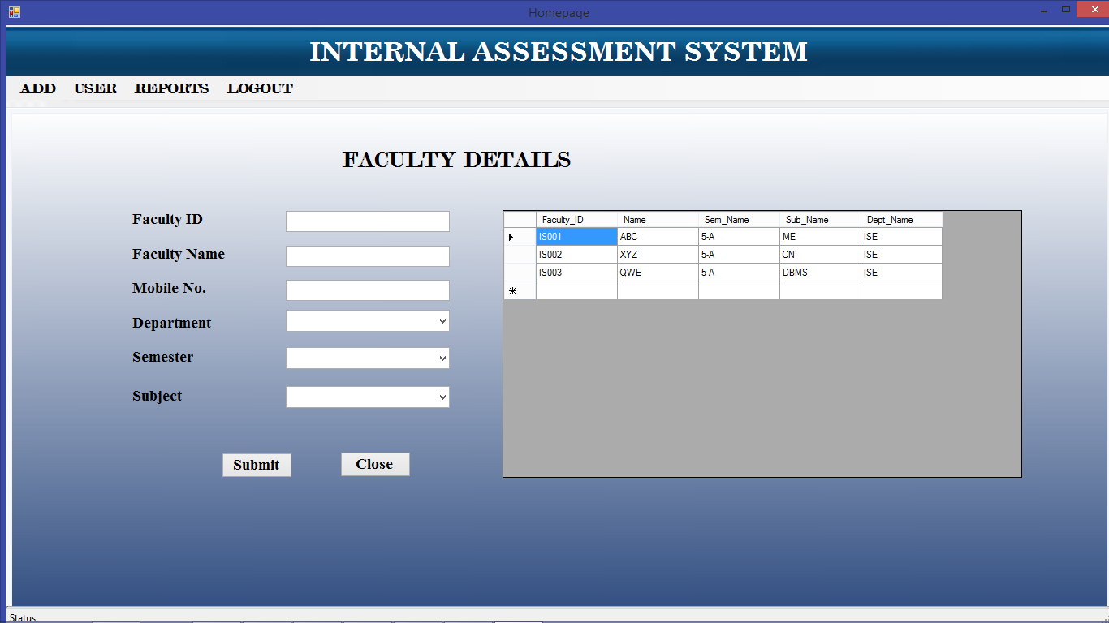

This screen shot contains to enter the faculty details. Each faculty will be having faculty ID, we will enter the faculty name, mobile no of the faculty, department. we will enter which faculty will handle the he semester and subject name. then we will submit the button. or close the button.

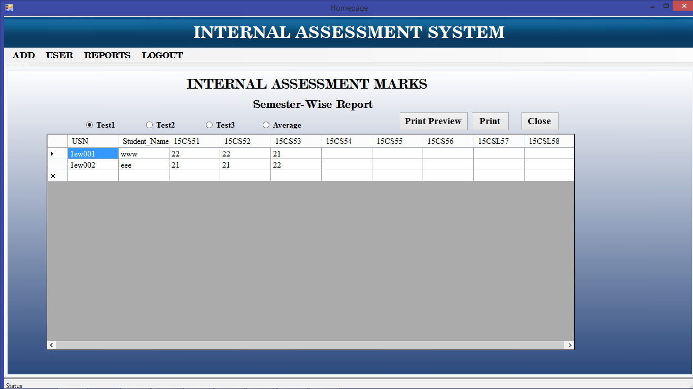

In this screenshot faculty will the internal assessment marks for each and every test. after this we can take the print out of the report and we can view the report if not we can close the close button.

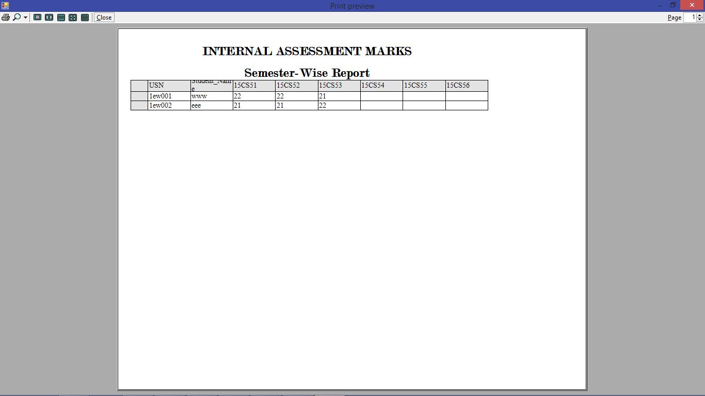

If we want to take the semester wise report we can take the semester report also.

**STAFF LOGIN**

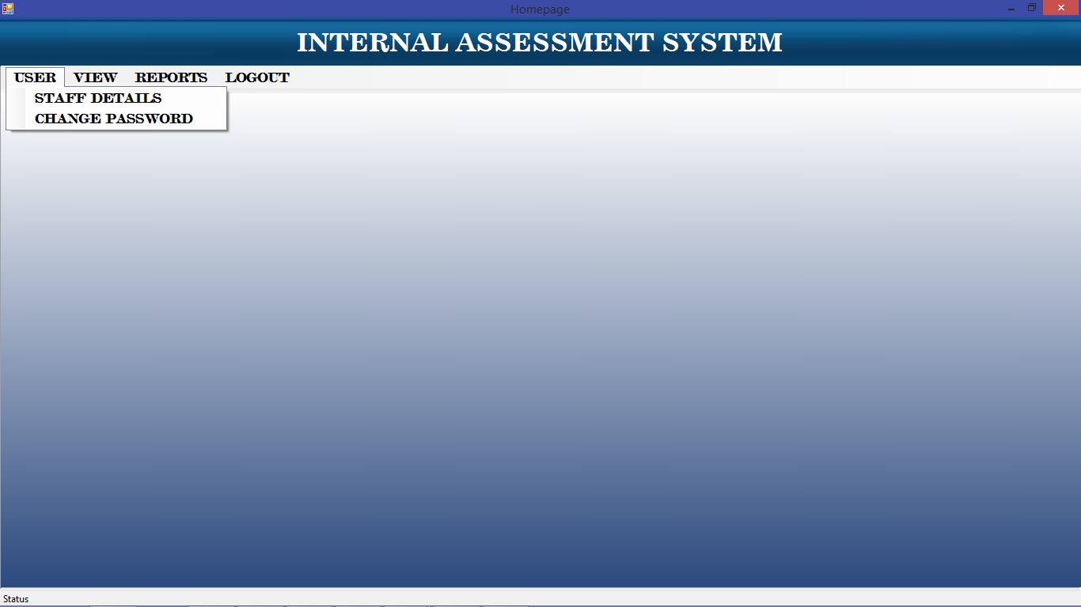

In user button it has staff details and change password link. In faculty details Faculty can enter the details. and also can change the password.

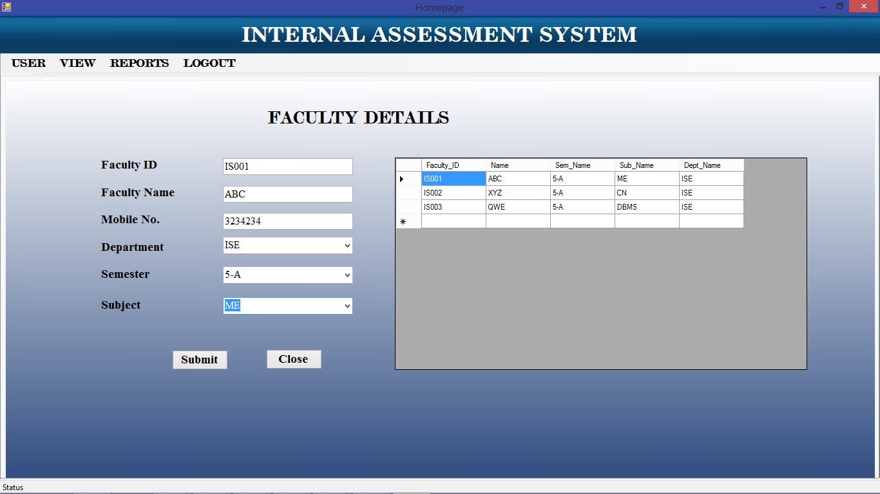

This screen shot is the Faculty details. were faculty will enter their details which will stored in the database after submitting the button.

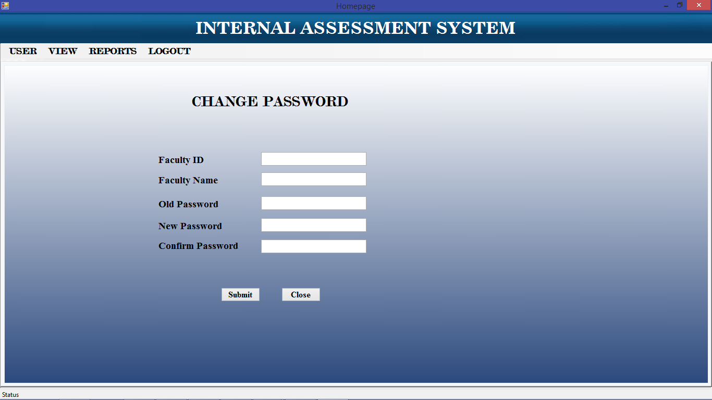

If faculty want to change their password faculty can change by clicking change password link.

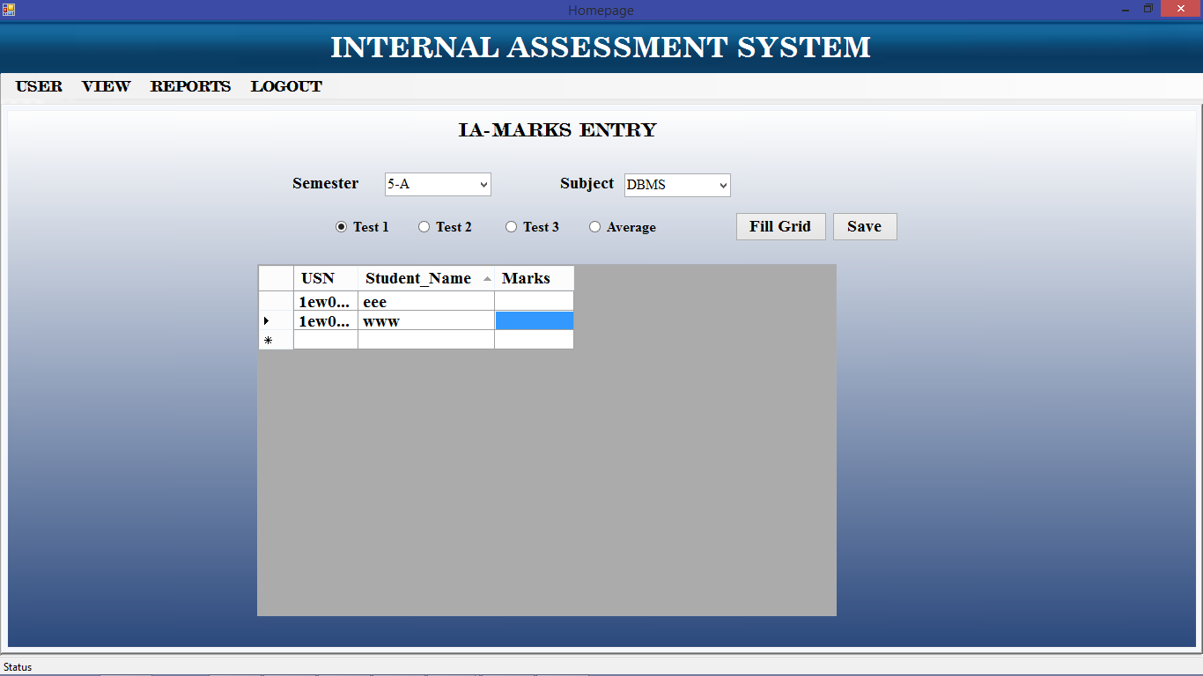

In this screen shot we can see the IA-Marks entry were faculty will enter the marks of each students.

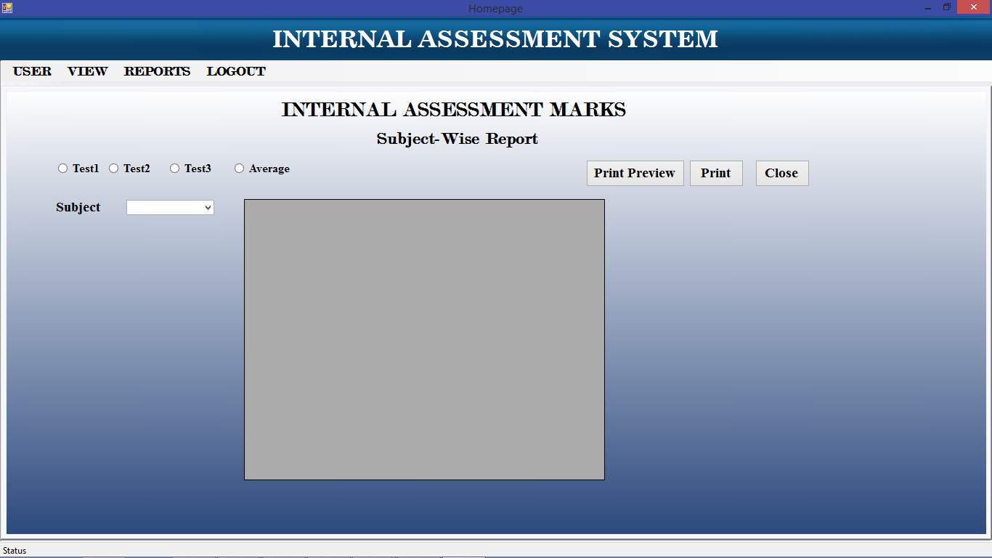

In this screen shot Faculty can take the report of each and every subject wise.

**STUDENT LOGIN**

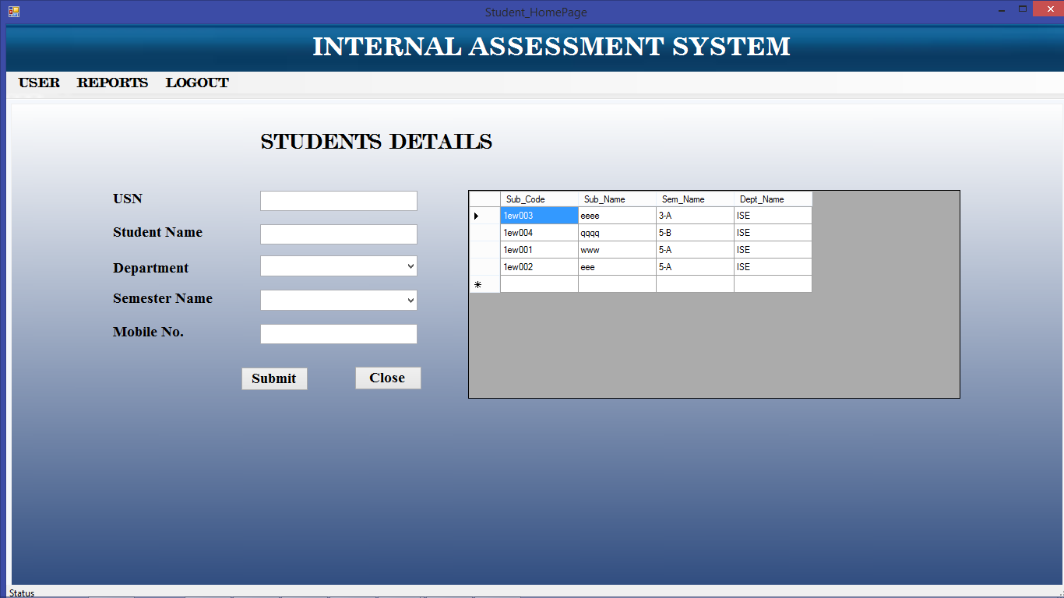

In this screenshot Student will enter the details. when the student enter the login page.

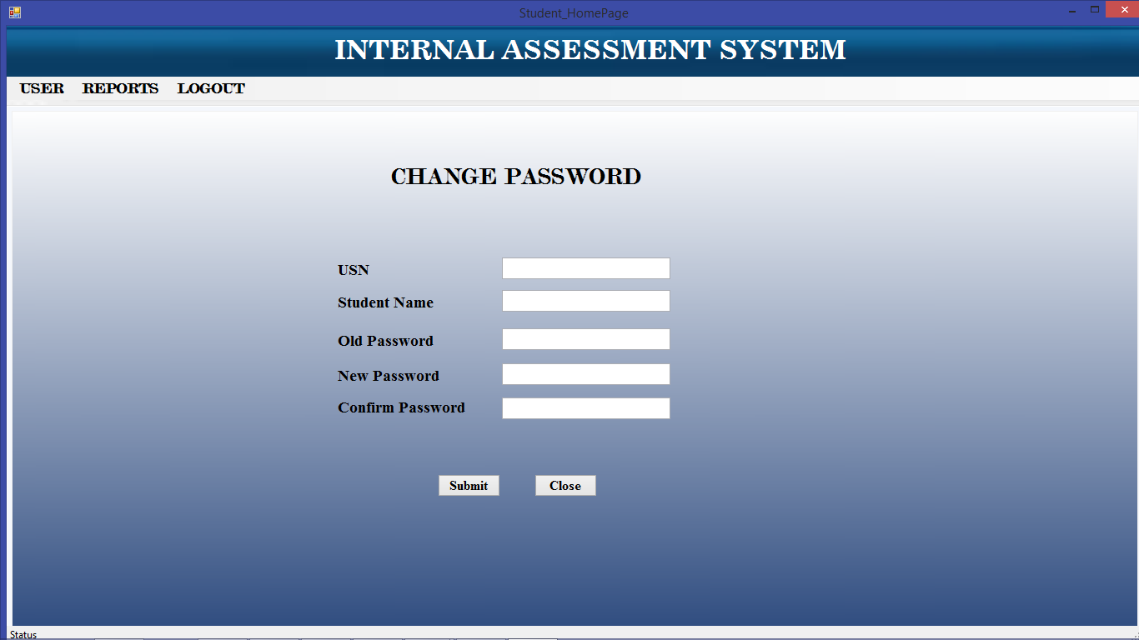

If student want to change the password students can change the password.

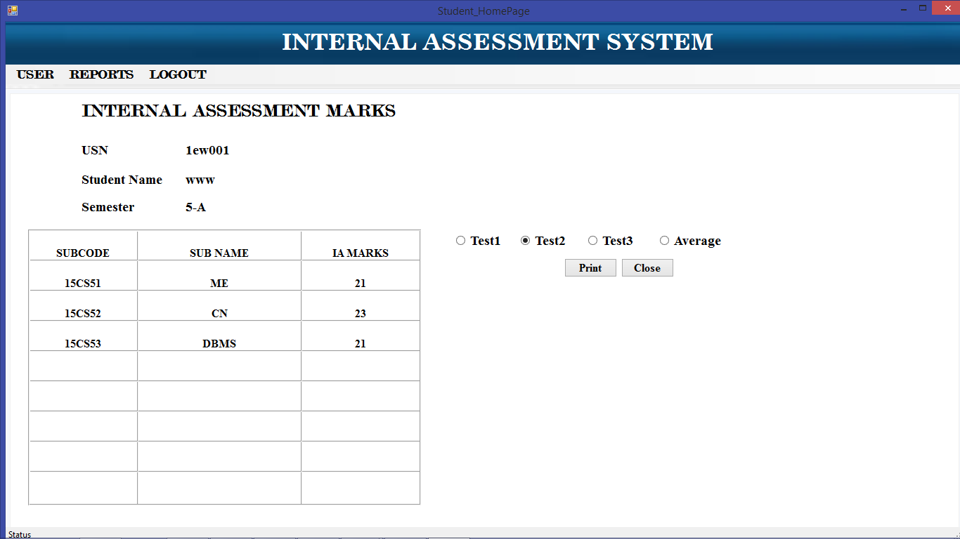

Student can take print out of each and every internal marks.